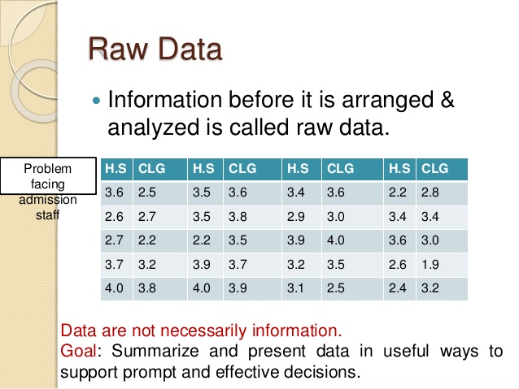
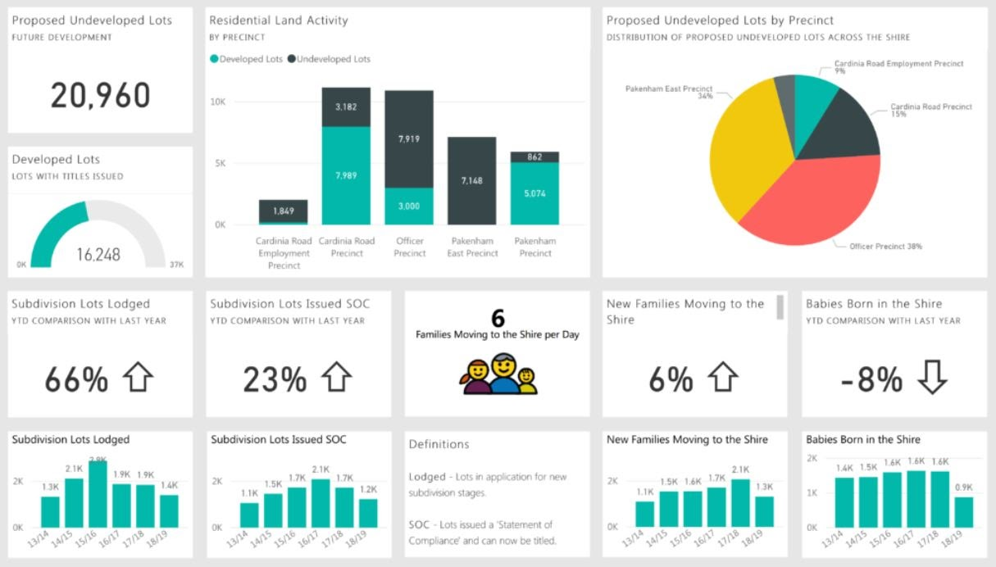
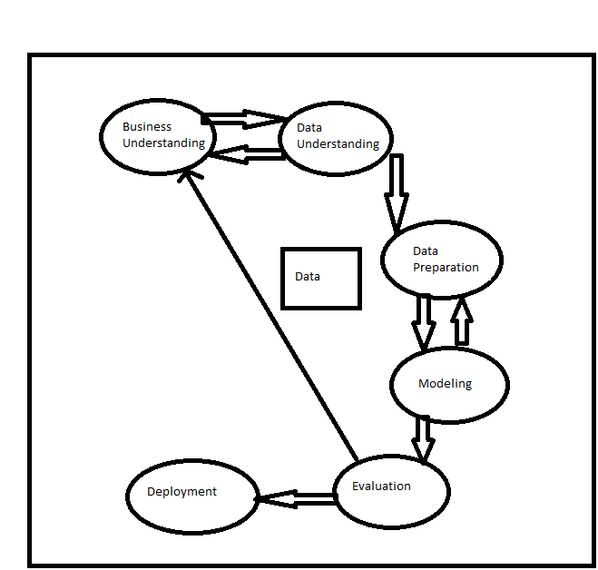
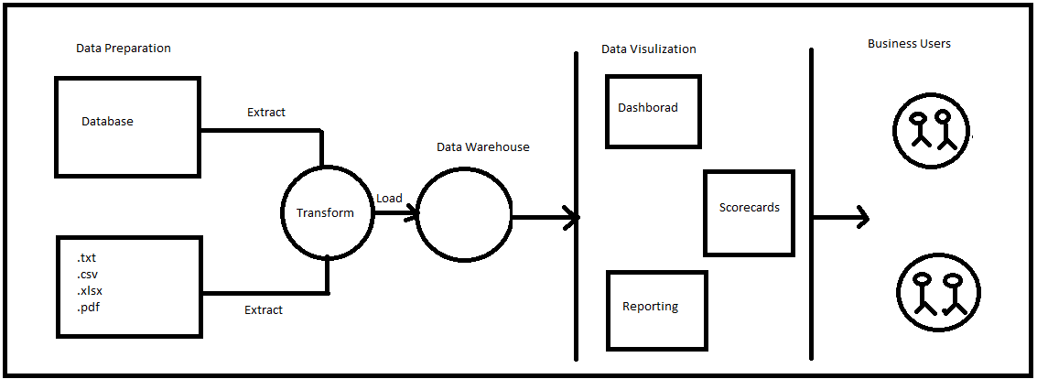
Power BI

Raw Data
- Raw data refers to data that has not yet been processed.
- Raw data, also known as primary data, are data (e.g., numbers, instrument readings, figures, etc.) collected from a source.
- Editing, cleaning or modifying the raw data results in processed data.
Visualizations
What is Business Intelligence
- Bi is the process of converting raw data into meaningful information.
- BI is a set of process architecture and technologies that drives the profitable business action.
- Bi is a method of collecting, storing and analysing data from business operations or activities to optimize performance
- Bi has a direct impact on organizational strategic and operational business decision. It impacts the revenue and financial model of the business.
BI Project Execution

Power BI
- Power BI is the business analytics solution that lets you visualize the data and share the insights to the concern stakeholders and the business owners.
Power BI Components
- Power Bi Desktop
- Power BI Service (Saas—Software As a Service)
- Power Bi Mobile Apps
Power BI begins by connecting to data sources and building a report in Power BI Desktop. You then publish that report from Power BI Desktop to Power BI Service, and share it so end users in the Power BI Service and Mobile devices can view and interact with report. This workflow is common and shows how the three main component of Power BI is used.
Power BI Architecture
Power BI Process
- Data Connection
- Data Transformation
- Data Modelling
- Data Visualization
- Data Reports
Data Connection
- You can talk to any data source with highly simplified Power Bi interface. Power BI can connect to any data source to bring the meaningful insights to the end users.
- It is simple to import any custom file into the Power BI.
- Connecting data from multiple data source can be achieved by anyone who is new to Power BI.
Transformation
- Post data loading it should undergo pre processing as per the requirements.
- Process is known as data shaping or data transformation
- Involves renaming tables and columns, changing the type of the data (number/text),modifying the row and so on..
Modelling
- Enhance the data to get more accurate the insights and analytics.
- It is achieved by working adding ample no of calculations, hierarchies, measures, relationships etc.
Visualization
- It is heart of Power BI
- It is a playing with variety of visualizations types.
- It is Working with visual tools and custom visuals.
- Business users get good analytics without writing a single line of code.
Reports
- Reports can be published and exported securely.
- Automatic data refresh can be set up which provides almost real time analytics and result.
- Various roles and authentication can be assigned as per the intended user.
Power BI Process Summary
- Create
- Publish
- Share
PBIX Format
- It is extension of power bi file.
Power BI Desktop Components
- Datasets
- Reports
- Visualizations
- Dashboard
Connecting Data(Data Connectors)
- Csv/Text
- Excel
- Microsoft Access
- PDF
- Folder
- Webpage from Power BI Desktop (Web Scraping)
- Live Stream
- MS SQL Server
- MY SQL
- Oracle
Excel Connector
- Select excel connection
- Select Sales Reports Dataset—Select orders table—Load it directly.
- Visualize Sales in terms of region or state and province
- Select Text table---Sales and State—Format it like—Font size, Border, Shadow
Csv file
- Select csv/text connection
- Select Geosales Dataset—Transform it--Remove rows--Remove blank rows
- Visualize Sales in terms of country or city
- Select cluster bar chart—Sales as value---City as axis—Format it— Chnage color
Pdf file
- Select pdf connection
- Select School data dataset—Transform it
- Update column headers
- Remove unwanted rows
- Rename column
- Remove top rows
- Rename table
- Visualize data by any visual
Folder
- Select folder connection
- Select EMP dataset -It contains multiple files-we can combine these files to generate the report.
- Rules---Same no of columns
- Column type, column name must be same
- Remove unwanted columns
- Make text table and use slicer to filter the records
Web
- Select web connection
- Paste link(Corona virus link) to load data
- Select table1-Transform it
- Remove world and blank rows
- Remove total
- Remove the continents —South America, North America, Europe, Asia
- Rename country column
- Select unwanted columns and remove it
- Use Donut chart and bar chart for visualization
Power BI connection types
Import
- The selected tables and columns are imported to the power bi desktop.
- Using the Import method, Power BI captures a snapshot of your data and caches it in Power BI Desktop.
- As you create or interact with visualization power bi uses the imported data.
- To see the underlying data changes since the initial import or the most recent refresh, you must refresh the data which imports the full dataset again.
- Importing the data is good only for small-to-medium datasets but is extremely
useful for Data Cleaning and transformations and we have a lot DAX function for analysis.
- The Import method of connection means that Power BI will cache the data that you’re connected to creating a point in time snapshot of your data. All of the interactions and filters applied to your data will be done to this compressed cache source instead of the actual data source itself.
Advantages
- (Performance) When you cache your data you are able to take full advantage of the Vertipaq performance engine. Normally your report performance will be better using this method.
- (Greater Functionality) Unlike in Direct Query, you are able to use all M and DAX functions (notably all time intelligence functions), format fields however you desire, and there are no limitations to data modeling.
- (Multiple Data Sources) Using Import you are able to combine data sources from various data sources (data flows, databases, csv).
Disadvantages
- (Delayed Data) You can schedule up to 8 refreshes a day (Premium SKUs allow more), but you also need to consider the amount of reports you’re maintaining and how big the data sets are that you’re refreshing.
- (Data Size Limits) Import caches are limited to 1GB per dataset (can be increased in Premium). While the Vertipaq engine does a great job a compression, you will still need to consider this when choosing your connection method.
- (Can't Switch Back!) once you’ve selected Import, you cannot switch back to using Direct Query. So make sure you want Import before making the switch, or else you’ll have more work ahead of you!
Direct Query
- No data is imported or copied to the power bi desktop.
- A Direct Query connection will run queries directly to your source at run time.
- The schema of the table is copied into the power bi desktop and all queries are directly done in the data source.
- Direct Query should be used for large datasets/big data as importing that data onto Power Bi model can slow it down and reduce it’s performance drastically. But DirectQuery doesn’t support many DAX functions and some transformations so we should be careful about that.
- When using the Direct Query method of connection, your dashboard will be directly querying the data source at run time. Every filter and interaction with the report will kick off further queries. No data is imported into Power BI so you are always querying the data that is present in the data source itself.
Advantages
- (Data Timing) Data is queried from the data source so you are getting the most up to date data. The report refreshes occur every 15 minutes.
- (Smaller File Footprint) Since you are not caching your data when using Direct Query, your Power BI Desktop files are much smaller and easier to work with (faster saving, publishing etc.)
- (Less Storage) No cache means not having to store that compressed data on Power BI Service, so you don’t need as much storage capacity on Service.
Disadvantages
- (Slower Performance) Because you’re querying the data source at run time, you might be competing with other users for bandwidth. You’re also not taking advantage of the compression of the Vertipaq performance engine.
- (Limited Transformations) You are not able to use all of the normal Power Query transformation features. Particular DAX functions are not available in this method as well. So if your data is poorly structured or needing lots of transformation, sometimes Direct Query is not a viable option.
- (Less Storage) No cache means not having to store that compressed data on Power BI Service, so you can increase storage capacity on Service.
Live Connection (Analysis Services)
- In live connection we just have a connection string with the schema and the data.
- Any modelling if needs to be done need to be created in the analysis service.
- Basically we work with tabular model.
- Any report level measure should be created in the analysis service.
- doesn’t support any kind of transformations on data
How to Choose a Method Based on Organizational Strategy
- let’s talk about how your organization can game plan what method to use.
- Beyond the pros and cons listed above, there are a couple of factors that need to be considered when deciding your method. Lots of cloud based services like Snowflake will bill you based upon usage, so if you’re using Direct Query with lots of users you’re going to be using quite a bit of their services. Add in multiple reports and teams and then you might start running into a big price tag from the service provider. All of this depends on what service you’re querying and what they’re price is for said services, but you need to take that into consideration.
- On the flip side, Microsoft is going to charge you for the capacity that you have on Power BI Service. If you are going to be using Import for every report and every team, then you’re bound to be storing more data on your Service instance. Depending on how much capacity you need, this need for storage could drive your cost up, but you also aren’t going to be charged for usage.
- Both of the previous points will need to be balanced out with the requirements for data transformation, data sources, and performance as well the element of cost.
Is Import faster than direct query?
- It certainly can be, and more often than not, it is. There are a ton of different factors that determine load time including the size of your data set, but generally Import is going to have a better load time than Direct Query.
Can you use DAX in direct query?
- You can use DAX in Direct Query, although some of the functions that you are able to use are limited. Using Import mode ensures that you are able to use all DAX functions.
What are some Power BI import vs direct query limitations?
- A limitation to Import is that your data is only as fresh as your latest refresh. Sometimes refreshes can fail and cause delays in getting updated data. On the other hand, while Direct Query will provide you with the most current data, this method can also mean slower performance and more limited DAX capabilities.
Power Query Editor
- Business users spend up to 80 percent of their time on data preparation, which delays the work of analysis and decision-making.
- Power Query is a data transformation and data preparation engine. Power Query comes with a graphical interface for getting data from sources and a Power Query Editor for applying transformations. Using Power Query, you can perform the extract, transform, and load (ETL) processing of data.
- Power Query enables connectivity to a wide range of data sources, including data of all sizes and shapes.
- Power Query offers the ability to work against a subset of the entire dataset to define the required data transformations, allowing you to easily filter down and transform your data to a manageable size.
- Power Query queries can be refreshed manually or by taking advantage of scheduled refresh capabilities in specific products (such as Power BI) or even programmatically (by using the Excel object model). Because Power Query provides connectivity to hundreds of data sources and over 350 different types of data transformations for each of these sources, you can work with data from any source and in any shape.
Take Sales Report
Practice the following steps
- To change the data type of any column--Click on icon--You can change the data type of any column
- Select Sales column--Remove the decimal point value--Right click on it--Transform--Round
- Still data type is decimal---So click on icon and change datatype to whole number
- Undo all the changes
Transform and add menu have so many options common.
Extract option from transform and add menu
- Extract the first name from the customer name column by using transform menu
- Extract the first name from the customer name column by using add menu
- Select any Date Column and use extract option from add menu to extract (Year,Month,Quarter of the year,Day of the year,Name of the day etc)
- if you want to start quarter from April then you have to create your own date table using m function
Split Column
- Select the column you want to split. There are many option(Delimiters) based on that you can split any column.
Custom Column From Add Menu
- It is used for calculations.
- You can use M Functions or M Queries or M code to calculate some derived attributes based on some existing attributes.
- Like you have two columns—Quantity*Sales---(You want to generate new column Revenue)--Afer that Change data type to decimal
Text Transformation
- Use Excel Connector and Take Transaction Details Data set
- Remove first row and last row
- Select Period description column and Use split column option--by delimiter-each occurrence of the delimiter
- First two column are unwanted so remove it.
- Select two column--right click--merge column option—name it start date-change data type to date
- Right click start date--duplicate column--rename it end date
- Right click on end date--transform--month-end of the month--close any apply
- Select text table—period id,start date—if it display date hierarchy--so you have to select a particular option either date hierarchy or startdate.
- Select period id--click--select don't summarizing option--change data format--select start date--column tools--format
Data source setting
- If you change the location of the file or change the filename then report will throw you error.
- To change the source go to home menu-transform data-data source setting-chnage the source.
How to create a group of facts and dimensions tables
- Connect Access Database-Global Trends—accdb(extension)
- Select all the tables--Transform it
Two types of tables
1)Dimension Table---we can not perform mathematical operation on it.(it is used as a reference table or dimension table Like Regions,Product)
2)Facts table (like Sales Table,Profit Table,Cost Table or Discount Table)

- You can create group for dimensions table and facts table
- Rename all tables from bottom like Sentiment,Sales,Product,Manufacturer,Region,Date
- Now Here you can observe that sales is a fact table and product,manufacturer,region,date are the dimensions table.
Process to create a group
- Rght click on queries area---Select new group—Named it (Dimention Table) and add the description(These are all dimension table)--OK
- Now drag all dimention table to this group
- Right click on dimention table group and you can find three options like Ungroup,Delete group and Rename group
Now Here we have sales table and it is from access database now I want to use append queries option to append data from other source file like excel which is having same table structure as sales table.
Append Queries
- Combining different queries(tables) data into a single table
- for example first table(50 rows) and second table(150 rows)--Append result(200 rows)
Two options for append queries
Append Queries
- It will not keep the source table that means if two tables are used it will change one source table.
- for example A & B two table are there then it will append data from B to A so A table(source table) will be changed.
Append queries as new-
- It will keep the source table and new table will be created.
Process
- Connect new source
- Choose folder connection
- Connect folder gt--Transform--Combine files –OK
- Rename gt file as new sales
- Select sales table—Go to home menu
- Select-append queries as new option
- It will create new table
- Rename it Updated Sales
- If there is an extra columns remove it like source
How to use custom column option
- Go to add column menu
- Go to custom column
- Give column name as Country Name
- Write m code-if country=null then 'USA" else country
- Remove extra column country now
- Change datatype to text of new column
- Now close and apply changes--goto data model view it will show you all the tables.
- Now in power query editor there is an option not to load Sales and New sales source table ino the model
- Go to transform data
- Go to power query editor
- Right click on Sales table one option is there (enable load)
- Unchecked the enable load option for both Sales and New sales table--close and apply
- Now these two source tables are not available in data model view
- Now we can also perform merge queries option on above data.
Merge Queries(It is similar as SQL joins)
- In both queries(tables) must have at least one column with same datatype
- So here we can take perform merge between product and manufacturer table.
- Here manufacture id is common column in both tables.
Process
- Select Product table
- Select merge queries as new
- Select the second table manufacturer
- Select manufacturer id column in both tables
- Select any type of join like
- Inner-------Matching rows from both table
- Left outer join--Matching rows from both table+Unmatched rows from left table
- Right------------Matching rows from both table+Unmatched rows from right table
- Full--Matching rows from both table+Unmatched rows from left table+Unmatched rows from right table
- Left anti--A left anti join returns that all rows from the left table which do not have a match in the right table
- Right anti--A right anti join returns that all rows from the right table which do not have a match in the left table
- You will get result a new table.
- To properly understands all the joins use join operation excel file.
Conditional Column(Same as case expression in SQL)
- No I want to create a new column which contains some values based on certain conditions.
Process
- Select Updated Sales table
- Select zip code column
- Got to add column menu
- Select the conditional column
- Named as Zip Code Type
- Write a code like
- If zip contains 98 then
- Global
- Else if zip contains 908 then
- Local
- Else
- Others
- It will create new column which contains global,local and others as per our condition.
How to add index column in your table
Process
- Select Updated Sales table
- Go to add column
- Select index columns—It will display you three options
- From 0
- From 1
- Custom
- Select any one from this
- It will include the index column in your table
How to perform pivot,unpivot operation
- Go to Home
- Select New data source
- Select excel connection
- Select column operations Data set
- Select Columnrows Transpose2 and Unpivot1 table
Pivot and Unpivot operation
(https://databear.com/power-bi-pivot-and-unpivot-columns/)
(https://radacad.com/pivot-and-unpivot-with-power-bi)

Pivot---You turn rows to columns (That means it summarize the data)
Unpivot--columns are transformed into rows.
Process
- Select unpivot1 table
- It contains summarize data that means it is categorized into years and sales.
- I want single column for all the years and second column for values associated for each year.
- Select one blank column column1 first and remove it
- Remove blank rows at the end—Select remove bottom rows- Enter no of rows 1
- Now to use unpivot option select first 4 columns(product category,region,customer name,product name)
- Right click on it—Select unpivot other columns
- It will create two new column for attribute and value and it will create group in terms of region,customer name,product name etc.
- Rename attribute column as years
- If you want to perform pivot option then you just undo this operation so you will get original summarized data again.
- Otherwise you can use pivot column option
How to use Pivot Column option
- Select Years column
- Go to transform menu
- Select pivot column option
- Select value column
- you will get original summarized data again.
How to perform transpose operation
(https://docs.microsoft.com/en-us/power-query/transpose-table)
- The transpose table operation in Power Query rotates your table 90 degrees,turning your rows into columns and your columns into rows.
Process
- Select Transpos2 table
- Now observe this data you can not perform direct transpose option on this data.
- First you have to perform some promotion or demotion operations on this data.
- Now I want to perform demotion operation on column header of this table it contains column headings.
- I want this column header row as a first row of data or records.
- For this go to the transform menu—Select option first row as header—There are two option
- 1)Use first row as a header
- 2)Use header as a first row
- Now select second option use header as a first row.
- So column headers will be demoted to row level.
- Now go to the transform menu again and use transpose option and select first row as a header you will get result of transpose.
Different types of filters
There are three types of filters you can apply in power BI.
1) Filter in Power Query Editor
2) Filter while applying DAX(Filter as a function)
3) Filter in visualization

1)Filter in Power Query Editor(It is just like select with where clause in SQL)
It allows you three kind of filters.
1)text filter
2)number filter
3)date filter

Text Filter
- It is case sensitive
- Select Columnrows table
- Select any text column
- Select down arrow key in the column
- Select text filter
- You have to put conditions as per your requirements
- If you go for search option instead of text filter you have to just write text in any case here it is not case sensitive and you can apply a text filter over here also.
Number Filter
- Select any numeric column
- Select number filter option or search option.
- If you select number filter option then you will get same options same as text filter
- You can give any conditions to filter the rows.
- If you go for search option instead of number filter you have to just write a number and you can apply a number filter over here also.
Date Filter(Mostly date filters are applied at DAX level because of power full functionality of DAX with date)
- Select any Date column
- Select date filter option or search option.
- If you select date filter option then you will get same option as other filter
- You can give any conditions to filter the rows.
- If you go for search option instead of date filter you have to just write a date and you can apply a date filter over here also.
Some Row Level Transformation
- Go to the new source
- Connect Excel
- Select Row operations Data set
- Select row transformations table
- If you observe the table data you can see the column headings are not proper.
- So go to the home -Use first row as a header
- You can see some dotted lines in under one of the column means it contains some error.
- Now how to remove this error
- You can remove this error in two ways depends upon scenario.
- If you want to remove this error
- Select remove rows option
- Select remove errors
- Instead of removing this error you can replace this error with some value.
- Go to the transform menu
- Select replace value option
- Write value to replace the Error
- Go to the remove rows option and remove bottom rows which contains null values
Number Transformation
- Connect Excel
- Use Number Transform Excel dataset
- Load Data and Number tables
- First in data table got to the home menu and select use first row as headers
- Remove error rows
- Remove bottom two rows
- Now select amount column and use operation from statistics and standard option like Sum,Min,Max,Avg,Add,Multiply,Divide
- Select any numberic column--Test information option (Is even,Is odd)—It will give you true or false depends upon value.
- Sign option is used for positive or negative value(It returns 1 for positive and 0 for negative)
- Now select Numbers table
- Select East West North and South column-- Go to the add column—Statistics--Select sum
- It will do the sum of values of all column.
- You can also test add option from standard option
- But here you observe that if any value is null then arithmetic operations with null becomes null
- To solve this problem you can add one custom column with value 1 or 0 any
- Now select custom column—write 0 as value and then add columns with this custom column you will get result proper.
- Now select Data table-- Select invoice date column—Remove other columns from table
- Go to add column –Date—Start of the year option
- Now find the difference between two dates—Select both the date column-Select date-subtract days option -It will give you the difference between two dates.(no of days)
- Now change the datatype of third new column to duration and you will test option from duration option Like total hours,total minutes etc.
How to create date table manually by using m fuction open following link
https://www.mssqltips.com/sqlservertip/6756/power-bi-calendar-table/
Make date table by predefined script
- Got to transform data--Select new source---Select blank query option
- Select advance editor and copy predefined code here--OK
- It will ask you to enter
- Start Date--1/1/2019
- End Date 31/12/2020
- FYSTART month--4
- Named it as Dimdate--Close any Apply it
Data Modeling
It is one of the feature used to connect multiple data sources in BI tool using relationship.
A relationship defines how the different data sources are connected with each other and you can create an interesting data visualizations on multiple data sources.
Here What You Learn
- What are dimensions and facts table.
- You can learn how to create relationship between different data tables.
- How to create measures or calculations.
- How to create calculated columns and tables.
- How to create time intelligence measures
- How to work with DAX(data analysis expression) functions
- How to create date table
DAX Syntax
Total Sales=sum(sales[sales amount])
- Total Sales is measure name
- Sum is predefined function
- Sales is table name
- Sales amount is column name
- Go to connect—Select Excel-- Select file Lupin Dataset--Select all tables
- No need to do any cleaning because it is clean data so just click on close and apply.
- Go to the Data Model View—Remove all default relationship from data set.
- Now arrange the dimensions and facts table at different levels means all the dimensions table are on the top and all the facts table are at bottom.
- Here Product,Customer and Region are dimensions table and Sales is facts table.
- Here I have order date column here so we will need an important date dimension table.
How to create date table
- First know the date range that means from year 2019 to 2020
- Go to the Data view—Go to Home menu-You will have calculation option(New Measure, Quick Measure, New Column and New Table)
- Select new table option
Date = calendar ( “1/1/2019” , ”31/12/2020” )
- It will create Date column
- Select mark as a date table option--Select date as column-OK
- Now format this date column
- Go to right side select Date table—Select date column- You will have format date option enabled in upper menu.
- Select date proper format—Select DD-MM-YYYY
- Extract month number from this date
- Now go to the data view –Select new column
Month No=month(“Date”[Date])
- Extract month name from this date
- Now go to the data view –select new column
Month Name=format(“Date”[Date],”MMM”)
- Extract week day number from this date
- Now go to the data view –Select new column
weekday no=weekday(“Date”[Date],2)
- Extract week day name from this date
- Now go to the data view –Select new column
weekday name=format(“Date”[Date],”DDD”)
- Now do the sorting of two columns based on month no and weekdays no column.
- Select month name column--Go to column tools option –Select sort by column-- Select month no
- Select weekday name column--Go to column tools option –Select sort by column --Select weekday no
- Now you can either remove two extra columns weekday no and month no which we have created for sorting only weekday name and month name columns.
- Go to the data model view –Select column-Right click on it—You have two option
Remove
Hide from report view---You can use any one option from here
- Now go to the data model view and create the relationship
Two options
An automatic
Manual
- Select manage relationship—Select auto detect—Just avoid this option goto the manual
- To create a relationship manually tables must have common column with same data type .
- Column name need not be same but data type must match.
- Drag customer name column from customer and drop mouse on Sales table cusomer name index column.
- Same you can do for product id(product id),index(region id),date(order date) column.
- Now I want to find the total sales in sales details table for that I have two options
Create new column or Create new measure.
- If you select create new column option then your data set having an extra column so it will make your dataset heavy
- Instead of creating new column you have to create new measurr because it will create only a virtual formula.
- Now go to the data view –Select new measure
Total sales=SUMX(“SALES DETAILS”,[QUNTITY]*[UNITPRICE])
You need to understand difference between sum and sumx
- Sum is a column level calculations
- 1
- 2
- 3
- 4
- 1+2+3+4=10
- Sumx is row level calculations
- 1+0=1
- 2+1=3
- 3+3=6
- 4+6=10

Insted of creating a measure into the particular table you can create seperate measure table and put all measures into this table.
Like important measures table---It contains 5 important measure.
Time intelligence measure table--It contains measures thoses work on time component.
Sorting measures--Like Top performer,Top product

Total Sales = sumx('Sales Details','Sales Details'[Quantity]*'Sales Details'[Unit Price])
how to create a measure table
got to home menu
select enter data
write name as imp measures--ok
it will create a new table named as imp measures
now shift total sales measure from sales details table to this table
select total sales measure--got to the measure tools--home table
select home table as imp measure
so it will move this total sales measure to imp measure
remove blank column column1 from imp measure table
now collapse and expands the fields section

now goto the data model view and arrange
dimention table--first row
facts table---second row
measure tables like this--third row

How to calculate Total Cost measure
select imp measures table--right click--new measure

Total Cost = sumx('Sales Details','Sales Details'[Quantity]*'Sales Details'[ Unit Cost])

now check this measure total cost in card visual just like total sales

How to calculate Total Profit measure
now you have two measures total sales and total cost so you can calculate total profit

How to calculate Total Profit measure
select imp measures table--right click--new measure

Total Profit = [Total Sales]-[Total Cost]

now check this measure total Profit in card visual

now use these three measures into the report
select text table
select customer name and all three measures into text table

now how to format the measures

select measure--select measure tools--select $ option--you can have so many option--select any one like $
do this for all three measures

you can also constrol decimal point value by using measure tools

How to calculate Profit percetange measure

select imp measures table--right click--new measure

Profit % = DIVIDE([Total Profit],[Total Sales],0)

now use this measure in text table along with all previous measures

now format this measure-select Profit %--goto measure tools and select %

How to calculate Total transactions measure

select imp measures table--right click--new measure

Total transactions = COUNTROWS('Sales Details')

now check this measure total Transactions in card visual

now how to create time intelligence measures

go to home--select enter data--name it -Time Intelligence--ok

How to calculate last year sales
select Time Intelligence table--right click--new measure

Sales LY = CALCULATE([Total Sales],SAMEPERIODLASTYEAR(Date2[Date]))
remove blank column column1

now check this measure and compare total sales and sales LY measure

select text table--select date from date table
select total sales
select sales LY

this formual give last year sales on the basis of years only
so we can find the same last year sales by other formaula which will give some flexibility
like sales in terms of days or weeks or months

How to calculate last year sales by other formaula
select Time Intelligence table--right click--new measure

LY Sales = CALCULATE([Total Sales],DATEADD(Date2[Date],-1,YEAR))

last year means -1
last two year means -2

third argument is day,month,quater or month--so this is flexible
now test this measure with previous measure--It is a same

How to calculate last year Profit
select Time Intelligence table--right click--new measure

Profit LY = CALCULATE([Total Profit],DATEADD(Date2[Date],-1,YEAR))

now select text table--select date, total profit and profit LY

How to calculate year on year sales difference
select Time Intelligence table--right click--new measure

YoY Sales diff = [Total Sales]-[LY Sales]

select text table --select customer name,Total sales,Sales LY,YoY Sales diff

How to calculate year wise sales

go to home--select enter data--name it -Year Wise Sales--ok

it will create a new table

select year wise sales table--right click--new measure

Sales 2019 = CALCULATE([Total Sales],FILTER(Date2,Date2[Year]=2019))

remove blank column column1

select text table --select product name,2019 sales
it will give you error of data type

so change data type of year column to whole number

Sales 2020 = CALCULATE([Total Sales],FILTER(Date2,Date2[Year]=2020))

How to calculate average daily sales

select time intelligence table--right click--new measure

Avg Daily Sales = averagex(values(Date2),[Total Sales])

test this measure by using card

last 50 days average sales
last 50 days average cost
keep it in time intelligence table--you can do it yourself

go to home--select enter data--name it -Top Performer--ok

select Top Performer table--right click--new measure

find out top 5 customers in terms sales

Top 5 Customers = CALCULATE([Total Sales],FILTER(values('Customer Details'[Customer Names]),if(RANKX(all('Customer Details'[Customer Names]),[Total Sales],,DESC)<=5,[Total Sales],BLANK())))

select text table select customer name and this measure

select Top Performer table--right click--new measure

find out top 10 products in terms sales

Top 10 Products = CALCULATE([Total Sales],FILTER(values('Product Details'[Product Name]),if(RANKX(all('Product Details'[Product Name]),[Total Sales],,DESC)<=10,[Total Sales],BLANK())))

select text table select product name and this measure

Top 5 city = CALCULATE([Total Sales],FILTER(values(Region[City]),if(RANKX(all(Region[City]),[Total Sales],,DESC)<=5,[Total Sales],BLANK())))

select text table select city name and this measure

to count the distinct customer
select imp measure table--right click--new measure

Distinct Customer Id = DISTINCTCOUNT('Sales Details'[Customer Name Index])

test this measure with card

sales in terms of seasons
we have to divide the season basis on the month

go to home--select enter data--name it -Seasonal Sales--ok

select seasonal sales table--right click--new measure

2019 Summer Sales = CALCULATE([Total Sales],DATESBETWEEN('Sales Details'[OrderDate],date(2019,6,1),date(2019,8,31) ))

2019 Winter Sales = CALCULATE([Total Sales],DATESBETWEEN('Sales Details'[OrderDate],date(2019,12,1),date(2020,2,28) ))

2019 Spring Sales = CALCULATE([Total Sales],DATESBETWEEN('Sales Details'[OrderDate],date(2019,3,1),date(2019,5,30) ))

2019 Autuam Sales = CALCULATE([Total Sales],DATESBETWEEN('Sales Details'[OrderDate],date(2019,9,1),date(2019,11,31) ))

find last purchase date

select time intelligence table--right click--new measure

Last Purchase date=lastdate(salesdetails.orderdate)

days since last purchase=datedifference(last purchase date,today(),day)

test this measure with text table

select customer name,last purchase date,days since the last purchase

now suppose i want to add some new column in existing table

like in cusomer table i want to add new column last purchase date

go to the data view --select customer table
select new column

last Purchase = maxx(RELATEDTABLE('Sales Details'),'Sales Details'[OrderDate])

format it dd/mm/yyyy

go to the data view --select product table
select new column

Sales = sumx(RELATEDTABLE('Sales Details'),'Sales Details'[Quantity]*'Sales Details'[Unit Price])

format decimal point

now i want to segment this sales in terms of low high and medium

go to the data view --select product table
select new column

sales segment = switch(true(),'Product Details'[Sales]<3000000,"Low Sales",'Product Details'[Sales]<9000000,"Better Sales","High Sales")

Sales Segment2 = if('Product Details'[Sales]<3000000,"Low Sales",if('Product Details'[Sales]<9000000,"Better Sales","High Sales"))

select text table---select sales segment,total sales

you can also test with slicer or pi chart

how to find last n days of sales

for that take new page for report

select bar chart--select countryname and total sales
select sclicer--select order date---click right side of the slicer--select relative date
you can have option like

last 50 days or weeks or months etc
next
this

so it will filter your chart based on this slicer

quick measure--it is very dengerous--never used it

select total sales measure--right click--select quick measure--select filter value--total sales
country
austria
ok

it will automatically create measure without writing any dax

select total profit measure--right click--select quick measure

it will automatically create measure without writing any dax
year to date total
total profit
date
ok
total profit yTD

select text table--select date,total profit,total profit yTD
it will give you error--because of date format

select date hirarchy--now it will display you the result

because any quick measure work with only date hirarchy

how to use new table option--how to calcuate additional facts table

i want to create seperate facts table which contains sales details of only one country says germany

got to the data view select new table

sales germany = filter('Sales Details',RELATED(Region[Country])="Germany")

now create the relationship with new facts table just like a sales table

select new column

country = related(Region[Country])

